UML Diagrams

Of

Smart Tourist Guiding System

Activity Diagram

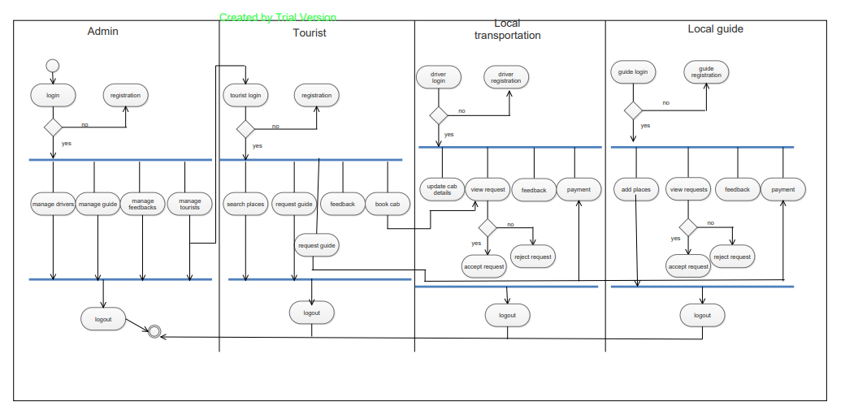

Class Diagram

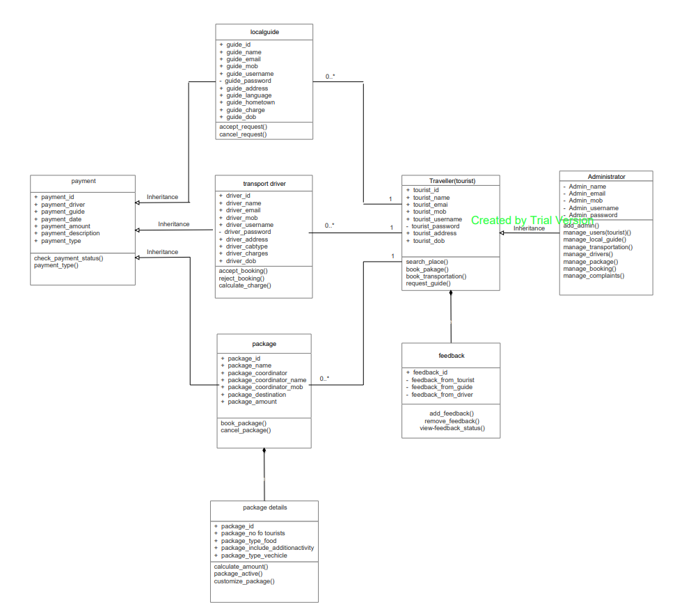

Component Diagram

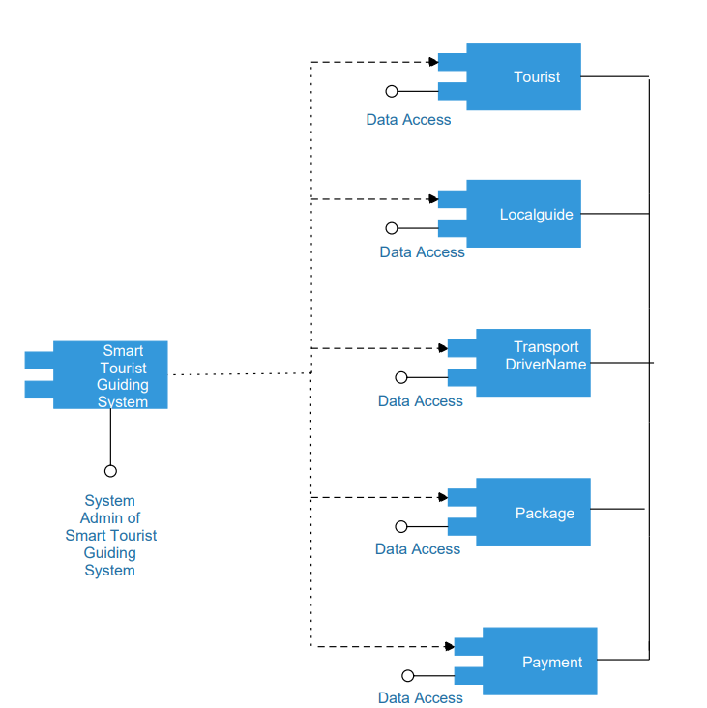

Object Diagram

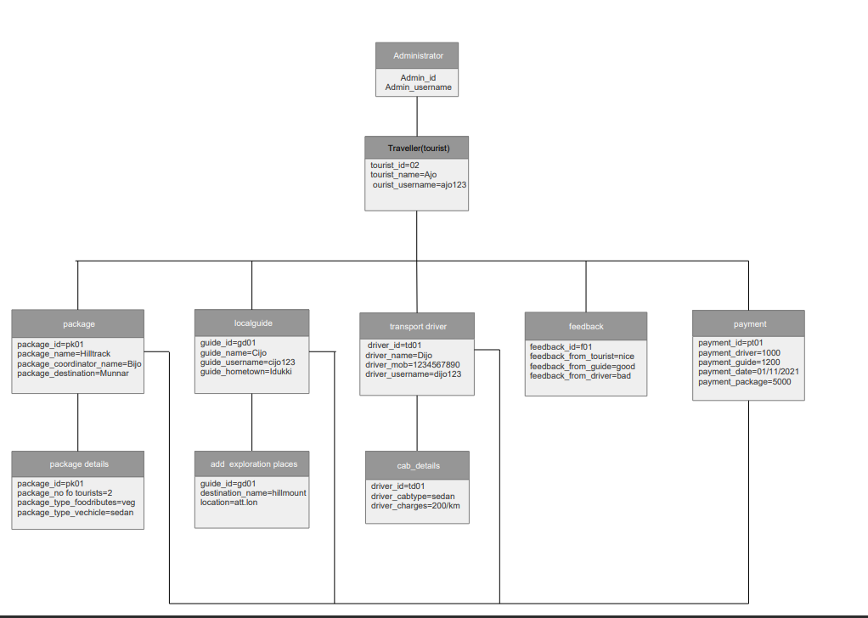

Sequence Diagram

Sequence Diagram of Admin

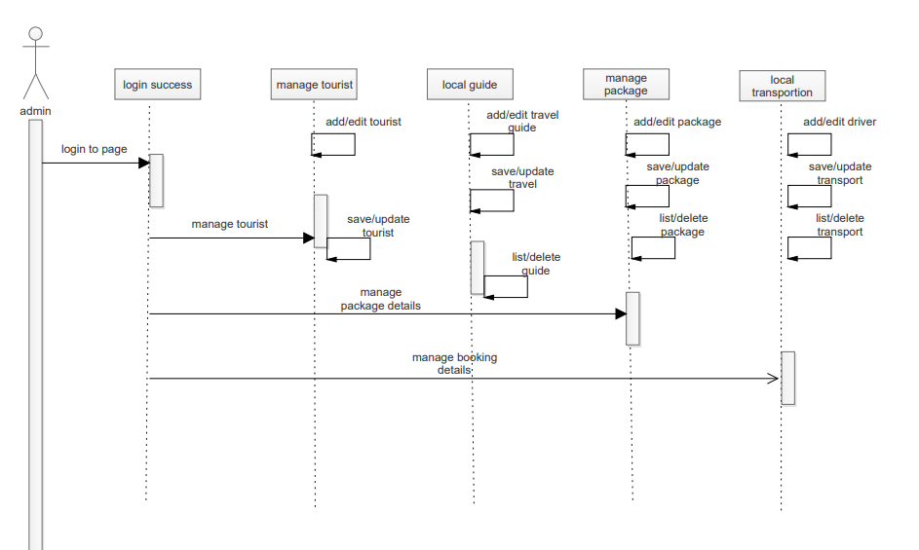

Sequence Diagram of Tourist

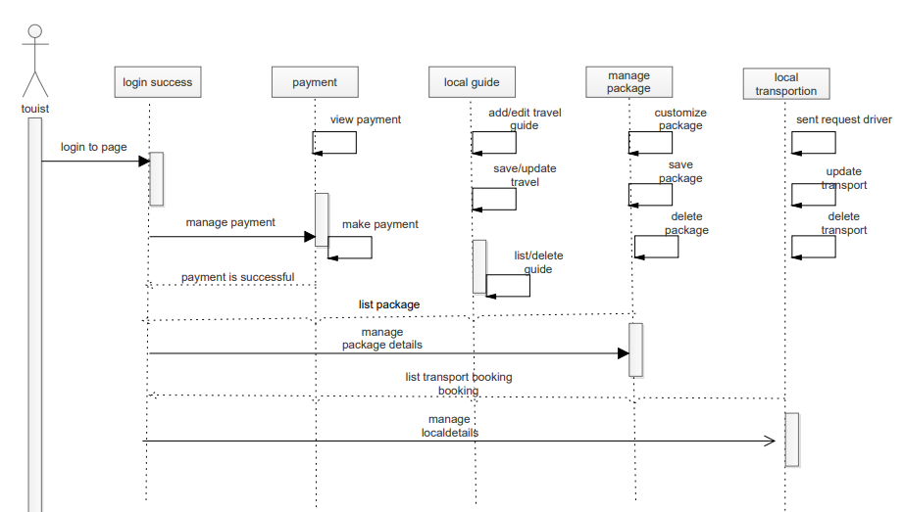

Statechart Diagram

Statechart Diagram of Tourist

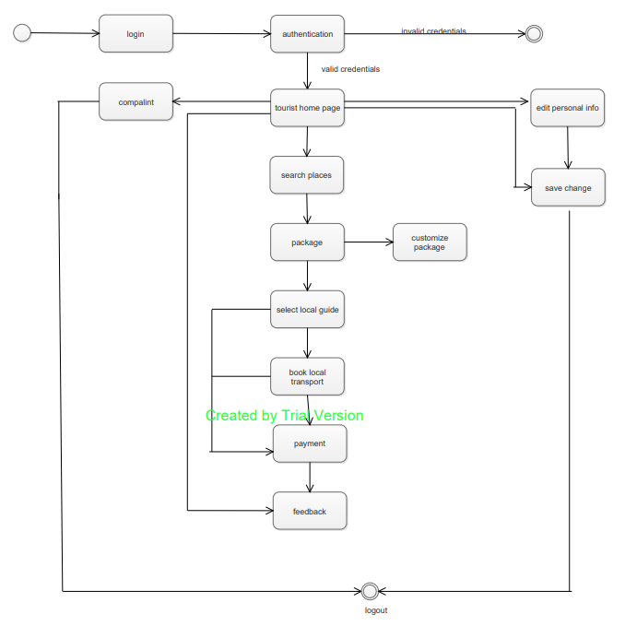

Statechart Diagram of Guide

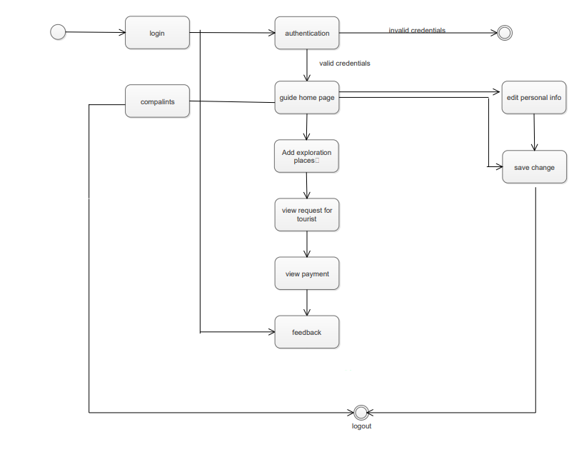

Statechart Diagram of Driver

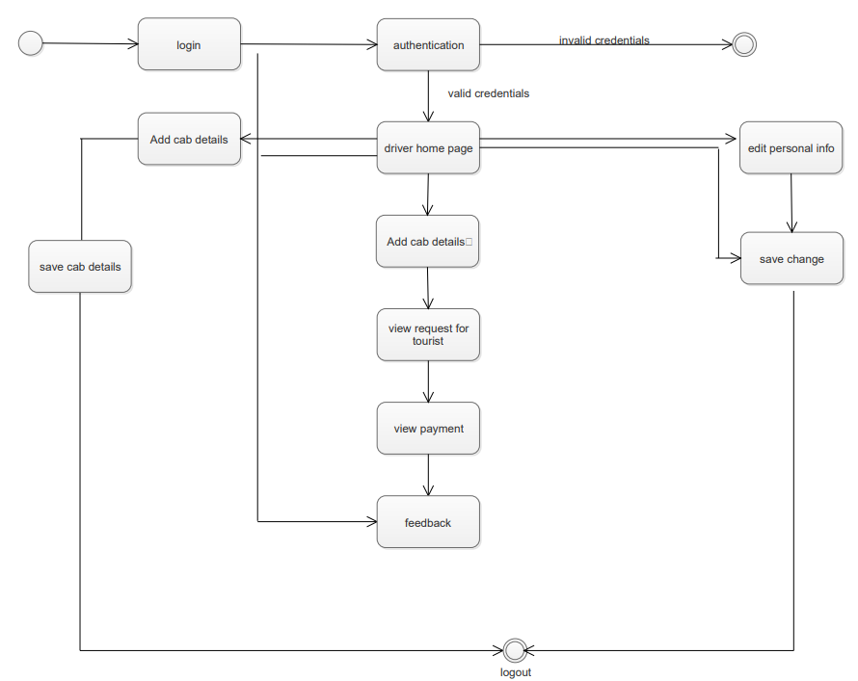

Usercase Diagram

Usercase Diagram without Admin

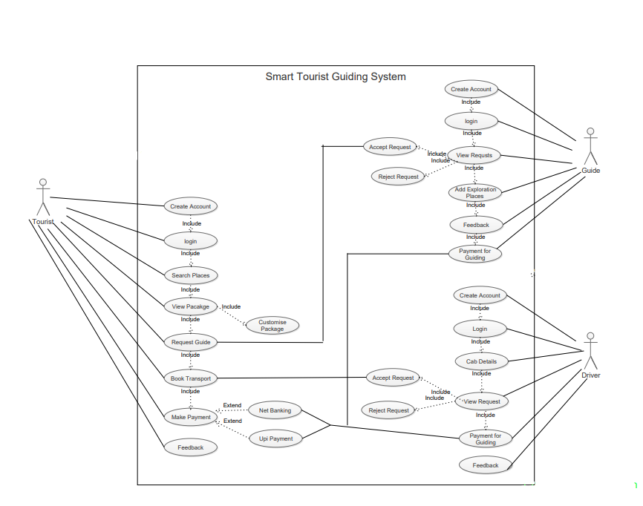

Usercase Diagram with Admin

